**ASSIGNMENTS ON DIGITAL MARKETING**

**NAME :** HARINI V

**DEPARTMENT :** BE COMPUTER SCIENCE

**COLLEGE :** 8151 DHANALAKSHMI SRINIVASAN INSTITUTE OF

TECHNOLOGY

**NAANMUDHALVAN COURSE**: DIGITAL MARKETING

**NM ID : 5967660529CA38A6FD45E**

**ASSIGNMENT 1:**

Create a blog or website using Blogspot and WordPress. Customize

the theme design and post new article with 500 words.

<https://roshthriesfancydoor.blogspot.com/2023/08/rosy-thries-fancy-door.html>

**ASSIGNMENT 2:**

Create a new Facebook business Page and Post one social media poster for your brand

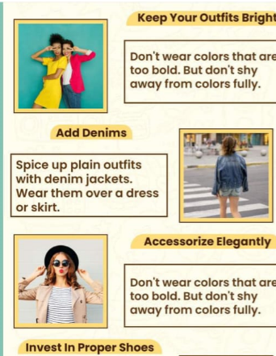

<https://www.facebook.com/roshthriesfancydoor?mibextid=9R9pXO>

**ASSIGNMENT 3:**

Create and design a social media advertisement poster using Canva.



**ASSIGNMENT 4:**

4.Create email newsletter design using MailChimp or Canva tool.

